Perfect Parfait LLC
NUTRITION & ANALYSIS
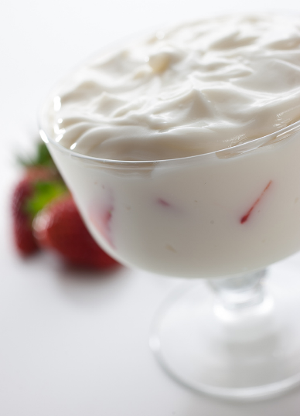
PRODUCT NAME: Farm Fresh Low Fat Strawberry Yogurt
PRODUCT CODE: 9614SB
PORTION SIZE: 4.0 oz., 113 grams
PACKED: 2 units per case
CASE NET WEIGHT: 28 lbs.
CASE DIMENSION: 15.625’’x14’’x5.875’’
PALLETIZING: 6 ti X 8 hi
MEAL CONTRIBUTION:
EACH 4 OZ FARM FRESH LOW FAT STRAWBERRY YOGURT: The equivalent of 1 serving of PROTEIN, contains minimum 9% of the 50 grams RDA for adults and children over four years of age¹.
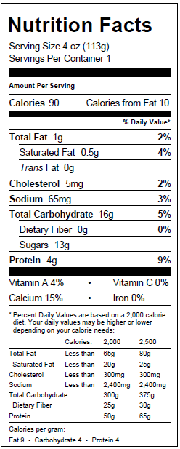
INGREDIENTS: Grade A Skim Milk, Milk, Strawberry Flavor [Sugar, Strawberries, Water, Modified Corn Starch, Natural Flavors, Fruit and Vegetable Juice Concentrates, Citric Acid, Potassium Sorbate], Cane Sugar, Modified Corn Starch, Less Than 2%: Pectin, Carrageenan, Potassium Sorbate, Cultures

ALLERGENS: MILK

SERVING DIRECTIONS: Portioned controlled servings through
Perfect Parfait fresh yogurt dispensers.

I certify that the above information is accurate at present
on this date.

Name: Russ Vulpitta Title: CEO

Signature: Date: March 2015

- Derived from: http://www.fda.gov/Food/GuidanceRegulation/GuidanceDocumentsRegulatoryInformation/LabelingNutrition/ucm064928.htm

