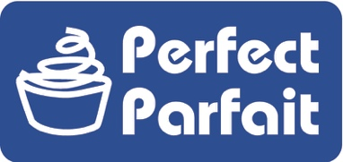

Nutrition Facts
1 serving per container
Serving size 100 g
Amount per Serving
Calories 100
% Daily Value *
Total Fat 1.5g 2%
Saturated Fat 1g 5%
Trans Fat 0g
Cholesterol 10mg 3%
Sodium 85 mg 4%
Total Carbohydrate 16g 6%
Dietary Fiber 0g 0%
Total Sugars 15g
includes 10g added sugars 20%
Protein 6g 12%
Vitamin D 1mcg 2%
Calcium 200mg 15%
Iron 0mg 0%
Potassium 260 mg 6%
The % Daily Value (DV) tells you how much a nutrient in
a serving of food contributes to a daily diet. 2,000 calories a day is used for general nutritional advice

Perfect Parfait Greek Vanilla Yogurt

This nutritional information was calculated from the Nutritionist Pro® nutrition labeling and formulation software and not from actual testing. Nutritionist Pro® is a trademark of Axxya Systems. Westby Cooperative Creamery considers this information to be an accurate nutrient
profile for this product.

Travis Anderson QA Manager
Westby Cooperative Creamery
tanderson@westbycreamery.com

Ingredients: GRADE A SKIM MILK, MILK, VANILLA FLAVOR [SUGAR, WATER,
MODIFIED CORN STARCH, VANILLA FLAVOR WITH OTHER NATURAL FLAVORS, CITRIC ACID], CANE SUGAR, MODIFIED CORN STARCH, LESS THAN 2%: PECTIN, POTASSIUM SORBATE, CULTURES

CONTAINS: MILK

